http://www.childwomenmin.gov.lk/en/institutes/childrens-secretariat/main-development-programmes

01. Programme to Provide a Nutrition Allowance of Rs.20,000 to Pregnant and Lactating Mothers.
Through this programme started in 2015, every pregnant mother registered with Medical Officer of Health Office was provided this nutrition allowance in the form of a nutrition pack worth Rs.20,000 consisting of all nutrients required by pregnant or lactating mothers for 10 months (through the use of coupons) up to April of this year. But a new method has been introduced to issue vouchers instead of coupons from May last year with the aim of making it convenient for the mothers to purchase the recommended food items and for convenient implementation of the programme.
Under this, 10 vouchers with a value of Rs.20,000 each are provided at the same time. It is possible to obtain the entire pack of nutritious food items within the last 06 months of pregnancy and the first 04 months of lactation. Rs.5,500 Million has been allocated for this purpose and the expenditure borne by the end of October is Rs.3,495.867 Million and approximately 1,747,933 nutrition packs have been distributed among the beneficiaries.
Plans are being developed to carry out this programme in a digital method using modern technology from next year and the pilot project in that regard is expected to be implemented by November this year focused on the Divisional Secretariats of Badulla, Kolonnawa and Thihagoda.
02. Programme to Provide Morning Meal for Pre School Children/Early Childhood Development Centers
Instead of the programme to provide a glass of fresh milk for Preschool Children/Early Childhood Development Centers that was implemented up to last year, the programme to provide morning meal for preschool children suffering from malnutrition was commenced from March 2017.
The main objective of this programme is to upgrade the nutrition level of underweight children in preschool age and encouraging children to attend preschool, training healthy habits from preschool days, providing economic benefits to poor families and making people aware of the public sector contribution towards human resource development of the country through total development are among the other objectives.
This programme is operative for Early Childhood Development Centers where children with minimum levels of knowledge of nutrition according to the data from the Ministry of Health and District Directors of Health Services. 51,213 children in 2,050 Preschools located in 206 Divisional Secretariats in the island have qualified to benefit under this programme accordingly. Rs. 300 Million has been allocated to implement this programme in 2017 and 49,320 preschool children have become beneficiaries by the end of October. The expenditure borne in this regard was Rs. 76.579 Million.
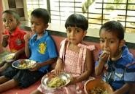 | 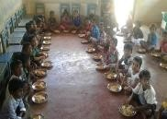 | 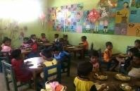
Programme to provide morning meal for Preschool children
03. Awareness Programme on Nutrition Conducted for Preschool Teachers.
The main objective of this programme is to raise awareness of Preschool teachers about the importance of the programme to provide breakfast for Pre School Children Early Childhood Development Centers operative from this year and about nutrition, simultaneously with the said progrramme. Accordingly, arrangements have been made to conduct 215 awareness programmes in the Divisional Secretariat Divisions where that programme is operative. Rs. 2.15 Million has been allocated as provisions in this regard and by the end of October this year, 184 programmes have been conducted spending Rs. 1.807 Million out of that amount.
04. Programme to Develop Day Care and Community Based Evening Care Centers for Children.
Construction of 07 Day Care Centers was commenced in 2014 to ensure the protection of Preschool children and to develop physical facilities under the project to prevent child abuse and violence against women (700 Million). Construction of Day Care Centers in Kilinochchi, Polonnaruwa, Matale, Batticaloa, NuwaraEliya, Anuradhpura and Moneragala was done accordingly and construction of another Day Care Centre in Panadura Divisional Secretariat Division was commenced in 2016.
Rs. 20 Million has been allocated for construction and improvement of Day Care Centers in 2017 and Rs. 17.214 Million out of that has been provided for the construction and development and opening of new Day Care Centers. Accordingly, preliminary work required for the construction of 02 new Day Care Centers in the Districts of Badulla and Gampaha and 02 new Day Care Centers in the two Divisional Secretariats of Dehiowita and Dambulla is being carried out.
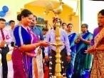 | 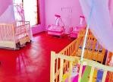 | 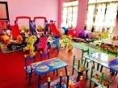
Opening of Batticaloa Day Care Centre

05. Programme to Provide Rs.250 Allowance (“Lama Diriya”) for Preschool Teachers.
Provision of a Rs.250 monthly allowance to teachers of Preschools/Early Childhood Development Centers was commenced on the interim budget proposals of 2015 with the aim of further strengthening the Preschool/Early Childhood Development Centre services. Accordingly, Rs.30 Million was allocated for this programme in 2017 and by the end of August 2017, Rs. 16.819 Million has been released to the relevant District Secretaries to provide this allowance to 5,499 preschool teachers.
06. Other Programmes on Early Childhood Care and Development
Provisions amounting to Rs. 65 Million have been allocated to implement programmes under this and programmes are implemented in the following manner.
6.1‘‘Senehe Thataka” Home Based Early Childhood Development Programme

The key objective of this programme is to bring about all round development of children by involving children in their early childhood in the household environment and the day today activities of the households. Awareness raising for parents, public officers, and youth etc. at Divisional Secretariat level is carried out under this.
In 2017, provisions amounting to Rs.1.31 Million have been allocated for 324 programmes at Divisional Secretariat level and 263 programmes have been conducted by the end of October this year. The financial progress of it is Rs.1.047 Million.
At the same time, provisions amounting to Rs. 0.356 Million were released to conduct 25 District level programmes under this and 20 programmes have been conducted by the end of October this year. The financial progress of it is Rs.0.301 Million.
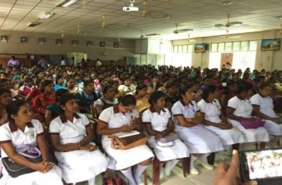 | 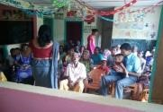
Awareness Programmes for Public Officers and Parents
6.2 District Women and Child Development Committees
The District Child Development Committees that existed up to now were set up as District Women and Child Development Committees from 2017 with an expanded role. Accordingly, the total amount allocated in 2017 to hold meetings of District Women and Child Development Committees with the participation of all responsible sectors to create a women and child friendly environment was Rs. 0.75 Million. By the end of October 2017, 40 committee meetings have been held and the expenditure in that regard was Rs. 0.288 Million.
6.3 Implementation of National / Divisional Coordinating Committees on Early Childhood Care and Development.
Rs. 1.163 Million has been allocated for holding National and Divisional Committees on Early Childhood Care and Development in accordance with the National Policy on Early Childhood Care and Development (2004). 3 National Level Committees, 357 Divisional Level Committees and 04 District Committees have been held accordingly and the expenditure for that was Rs. 0.616 Million.
6.4 Progress Review Meeting of the Early Childhood Development Officers.
101 Progress Review Meetings of District Early Childhood Coordinating Officers, who engage in field duties and Early Childhood Development Assistant Officers, who engage in duties at Divisional Secretariats, 07 Provincial Level Progress Review Meetings and 03 National Level Meetings have been conducted by now and an expenditure of Rs. 0.531 Million has been borne for this by the end of October 2017.
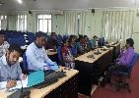 | 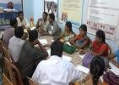
District Progress Review Meetings
6.5 Annual Forum of the Early Childhood Development Officers
This Annual Forum was held in Colombo in 2017 with the aim of introducing the Annual Action Plan of the Children’s Secretariat to the Early Childhood Development Officers serving at District and Divisional levels throughout the island and to make the District and Divisional level programmes more efficient and productive. Rs. 0.382 Million was allocated for this and that whole amount has been spent by now.
6.6 Review and Updating of the National Policy on Early Childhood Care and Development.
The National Policy on Early Childhood Care and Development launched in 2004 is being implemented at present and action is being taken to review and re – print the National Policy to suit current Early Childhood Development and Care requirements. The relevant parties are being consulted in that regard and Cabinet approval is to be sought for this National Policy after that. This is due to be printed and launched next year.
6.7 Maintaining the Network on Early Childhood Care and Development.
A Network on Early Childhood Care and Development (ECCD Network) involving government, non-government and private sector institutions and individuals working for Early Childhood Development in Sri Lanka has been established by the Children’s Secretariat and Rs. 0.11 Million has been allocated for this purpose. A preliminary meeting has been held in relation to that accordingly and the amount spent was Rs. 0.0862 Million. Further meetings are to be held in this regard in due course.
6.8 Updating the Minimum Standards Book ‘ Starting Right’ for Early Childhood Development Centers.
Preliminary work required to revise and print the Minimum Standards book for Early Childhood Development Centers has been carried out by now and Rs.1.213 Million has been allocated for that. It is due to be printed.
6.9 Programme to Introduce Early Childhood Development Standards
Early Childhood Development Standards (for children in the age group of 3-5 years) were launched at National level in 2015 and they have been named as “National Standards” and Cabinet approval has been obtained for them. These Early Childhood Standards have been prepared in the form of a Pre-school teacher training hand book and training programmes are implemented to introduce that to Pre-school teachers.
Similarly 149 training programmes were conducted last year for Pre-school teachers in all the Divisional Secretariat Divisions in Southern, Western, Central and Uva Provinces and 168 such programmes have been conducted this year in Sabaragamuwa, North Western, North Central, Northern and Eastern Provinces and the financial progress in that regard is Rs. 3.347 Million.
6.10 Develop a Curriculum for the National Diploma Certificate Course on Early Childhood Care and Development for Preschool Teachers and Providing Assistance to Preschool Diploma Course.
Preliminary work for developing a curriculum for the National Diploma Certificate Course on Early Childhood Care and Development for Preschool teachers has been concluded by now with the help of the National Apprentice and Industrial Training Authority (NAITA). In addition to that, Rs. 0.2 Million has been allocated for providing assistance for a Preschool Diploma Course. Its financial progress is Rs. 0.2 Million.
6.11 Programme to Register Diploma Courses on Early Childhood Care and Development.
The key objective of this is to ensure that one year Diploma Courses on Early Childhood Care and Development (Preschool Teacher Training) are of National Level Standards and to register them under the Children’s Secretariat.
62 National Level Diploma Courses have been registered under this. Rs. 0.01 Million has been allocated for that and the financial progress is Rs. 0.003 Million.
6.12 Research on Early Childhood Development and Care
5 Researches are underway at present on Early Childhood Care and Development. The relevant financial progress is Rs. 0.024 Million.
6.13 “Aruna Dakina Rata” Art Exhibition and Workshop of Children in their Early Childhood.
An annual all island art exhibition is conducted to enhance the creative skills of children in their early childhood. Paintings by preschool children are received to represent all parts of the island and this exhibition is held in Colombo with 500 drawings selected out of them and the relevant children are awarded prizes and certificates.
This programme was conducted on September 11th this year at the Youth Services Council premises in Maharagama. Provisions allocated for this programme amounted to Rs. 4.775 Million. Accordingly Rs. 2.317 Million has been released for conducting 331 drawing programmes at Divisional Secretariat level and the financial progress is Rs. 2.246 Million. 25 District programmes have been held to select suitable paintings for the national level “Aruna Dakina Rata” art workshop and award presentation out of those selected at Divisional level and the relevant financial progress is Rs.0.0669 Million. At the same time, the reported expenditure for the National Level art exhibition and award presentation is Rs. 2.388 Million.
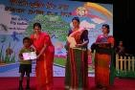 | 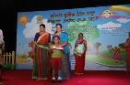 | 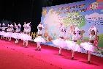
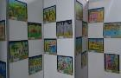 | 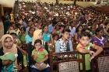 | 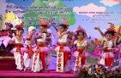
“Aruna Dakina Rata” National Programme
6.14 National Week on Early Childhood Care and Development
The National Week on Early Childhood Care and Development was held successfully this time as well from 14th to 20th of July. The target groups of this are Early Childhood Policy Makers, Pre-school children, Pre-school teachers, officers engaged in the field, parents, pregnant mothers etc. Accordingly, provision of educational equipment to Preschools, providing assistance to construct Preschool buildings under the model villages, awareness programmes and aesthetic programmes for children etc. have been carried out this year as benefits for those target groups.
Within this National Week public awareness progarammes on Early Childhood Care and Development were presented through media as well. The theme for the National Week this time was “Heta dina hinahena Pivituru darukela surakimu nirathuru” (Let’s always protect the future generation). In that, attention was paid to promote concepts of child friendly education in the society to build an environment that facilitates children’s smooth transition from Preschool stage to school education under the “Welikeliyen Pitu Atharata” programme (Programme on Child Friendly Education) currently implemented by the Children’s Secretariat.
The estimate for 07 National Level Programmes under the National Week on Early Childhood 2017 was Rs.2.161 Million and the financial progress of that is Rs.2.09 Million. For the Divisional level programmes the estimated value of provisions was Rs.7.247 Million and the recorded expenditure is Rs. 6.617 Million. Accordingly, 300 programmes for children and 289 programmes for parents at Divisional level covering all the Divisional Secretariats and 07 national programmes have been conducted by now.

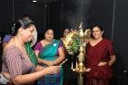 | 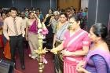 | 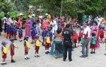
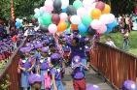 | 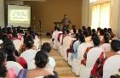 | 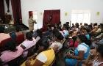
National ECCD Week Programmes
6.15 World Children’s Day
This year’s National Celebration of World Children’s Day under the theme “Lead children to their wonder world - along the path of love and affection” was held successfully in Anuradhapura on 01st of October 2017 led by the Minister of Women and Child Affairs Hon. Chandrani Bandara.
It was held with the participation of several invitees such as Hon. Ministers, Parliamentarians and Representatives from Provincial Councils, District and Divisional Secretaries and 800 children selected from several schools to cover the entire District of Anuradhapura.
Rs.6.9 Million has been allocated for this national programme through the Action Plan for 2017 and the expenditure recorded by now is Rs.5.948 Million. Rs.4.83 Million was released for 322 Divisional Secretariats as Rs.15,000 per Divisional Secretariat to implement various awareness programmes, workshops and entertainment programmes for Preschool children at Divisional Secretariat level to coincide with the National programme. 156 Divisional level programmes have been conducted and the financial progress is Rs. 2.335 Million.
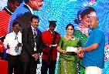 | 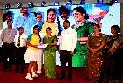 | 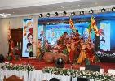
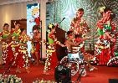 | 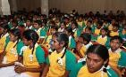 | 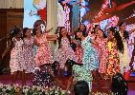
National Celebration for World Children’s Day
6.16 Model Villages Project on Early Childhood Care and Development
Villages selected from Grama Niladhari Divisions in selected Divisional Secretariat Divisions in the island are developed as “Early Childhood Development Model Villages” with the aim of making the people in them aware of and sensitive to Early Childhood Development.
Rs.12 Millon was allocated in 2017 for setting up such model villages. Out of the funds allocated, provisions worth Rs.11.83433 Million have been disbursed by the end of August 2017 to set up 22 model villages. Construction work of these villages is underway accordingly, and 3 villages in the Districts of Ampara and Kurunegala have been completed by now. Financial progress of that is Rs.2.665 Million.
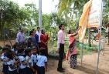 | 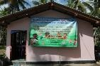
Model Village Project - Pallama
6.17 Programme on Early Childhood Care and Development in Emergency Ssituations.
Rs.3.711 Million was allocated to act on requests made in respective instances on requirements created in unplanned emergency situations, in relation to Early Childhood Care and Development. Under this, the programme to provide learning equipment and stationery as assistance for Early Childhood Development Centers in the Districts of Rathnapura, Kaluthara, Kegalle, Galle, Matara, Hambanthota and Colombo Districts that were affected by the flash floods was implemented. Rs.3.711 Million has been spent in that regard by now. UNICEF also has come forward to rehabilitate these affected Preschools and to provide the relevant equipment.
6.18 Printing the Home Based Activity Book for Early Childhood Development and the Training Manual Relevant to that.
The amount allocated for printing the Home Based Activity Book for Early Childhood Development and the training manual relevant to that is Rs.0.43 Million. Action has been taken by now to print the Home Based Activity Book for Early Childhood Development and the training manual relevant to that.
6.19 Media and Publications
Conducting programmes and printing leaflets to raise awareness of the public and the personnel engaged in this field and issuing entertaining publications for children in early childhood were carried out under this. Rs. 1.156 Million was allocated for this and the financial progress by now is Rs.1.156 Million
6.20 Development of Early Childhood Resource Centre and the Archive.
Rs.0.3 Million has been the estimate for obtaining the equipment required to improve the facilities at the Early Childhood Resource Centre of the Children’s Secretariat and for proper maintenance of the archive there and that work is under way now.
6.21 Awareness Programme Based on the Parenting Manual Book (Book on Best Practices in Bringing up Children)

Raising awareness of parents and the community regarding the best practices in bringing up children with the aim of bestowing upon the nation totally developed children in early childhood through the desirable inter-relationship that should be built between the child and the parents is done through this.
Under 3 main sections, the programmes are organized to be conducted throughout the year. District Coordinators for Early Childhood Development from the 25 Districts were trained as trainers at the beginning of the year and the financial progress of that was Rs.0.0335 Million. Then for the training of Early Childhood Development Officers of all the Divisional Secretariats by the District Officers provisions worth Rs.0.356 Million have been allocated. Parents belonging to each Divisional Secretariat Division are made aware of the correct methods of bringing up children by the Early Childhood Development Officers at Divisional level. The amount allocated for this third phase is Rs.1.324 Million. The financial progress of it up to now is Rs.0.584 Million.
6.22 Printing the Parenting Manual Book (Book on Best Practices in Bringing up Children ) and the Handbook Based on that .
Training of trainers programmes are conducted based on the book on Best Practices in Bringing up Children and this handbook is printed to be distributed among the Early Childhood Development Officers and the officers working in connection to the field of Early Childhood. Accordingly, printing a handbook based on the book on Best Practices in Bringing up Children with instructions and guidance for parents in conducting field awareness programmes is done through this. Work related to that is approximately completed.
6.23 Resource Pool for Early Childhood Care and Development
Provisions worth Rs.0.05 Million have been allocated through the 2017 Action Plan for the establishment of a Resource Pool for Early Childhood Care and Development. As specialist trainers are rare in the field of Early Childhood Development and Care, it is expected to train Early Childhood Development Officers attached to Divisional Secretariats in the island at present and train parents, youth, pregnant mothers and Preschool teachers through them.
Applications have been called from field officers working in the field of Early Childhood Development and Care for this. They are to be interviewed in due course and the selected candidates will be given advanced training in Early Childhood Development and Care to be used as experts in that field in awareness programmes.
6.24 Assessment Criteria for Early Childhood Care and Development
Assessment Criteria for Early Childhood Care and Development have been developed by now based on the Early Childhood Development Standards. Launching these Assessment Criteria was done on 25th and 26th of September 2017 at Sri Lanka Foundation Institute.
After the launching, these Assessment Criteria have been referred for printing. Rs.3.223 Million has been allocated for this purpose.
Subsequent to that, plans have been prepared to develop Assessment Criteria sets and hold Provincial level training programmes covering all the Early Childhood Development Officers and to inform the Preschool teachers through the Divisional level officers in the next year.
6.25 “WeliKeliyen Pitu Atharata” Child Friendly Education - Pilot Project
The period from 3 to 5 years is of greater importance for language development, personality development, socialization etc. Early Childhood Development Centers should make an active contribution for all these aspects. From that basis, the child in Early Childhood has to enter formal school. Even though this transition from Early Childhood Development Centre to formal school should be a smooth one for the child whether it happens so is debatable. Identifying the different roles and responsibilities of the preschool teacher in the preschool and the primary teacher in the formal school and developing a workable method for implementation in the field and follow up are the objectives of this project.
Rs.0.6 Million was allocated for this pilot project through the Action Plan for 2017 and arrangements have been made to hold 30 programmmes focusing on the Districts of Colombo, Anuradhapura, Kurunegala, Kegalle, Matara and Moneragala. 16 programmes have been held by now and the financial progress is Rs.0.320 Million.
6.26. Provision of Equipment for Day Care Centers where Children with Special Needs are Found.
Rs.0.264 Million has been allocated through the Action Plan for 2017 to provide learning equipment for Day Care Centers where Children with Special Needs are found. It is expected to provide assistance in the form of such equipment considering the requests received.
6.27 Special Projects at Divisional Level
Implementing appropriate project proposals selected from among the special project proposals that were discussed in relation to the issues identified with relevance to Early Childhood at Divisional Secretariat level is done here. Rs.0.4 Million has been allocated accordingly and Rs.0.35 Million has been released by now. Special projects are implemented in Horana, Welikanda, Ehaliyagoda and Thamankaduwa Divisional Secretariats under such allocation.

