**Is this an achievable aim?**

Saturday, October 13, 2018 - 01:00

[Visakha Tillekeratne -Consultant Food and Nutrition](https://www.dailynews.lk/line/visakha-tillekeratne-consultant-food-and-nutrition)

[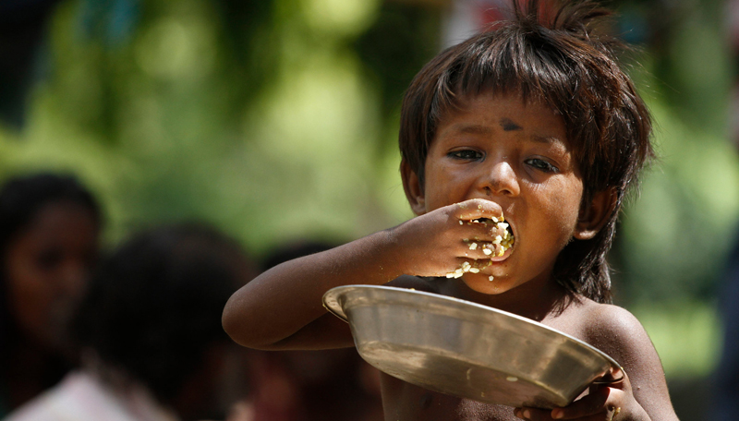](https://www.dailynews.lk/sites/default/files/news/2018/10/12/z_p06-Is.jpg)

The global population today is calculated as 7.2 billion. To feed this number at the recommended 500 g (2150 kilo calories) of food per person per day, 2.16 billion tons of food are required annually. Of the amount required, cereals comprise half, which amount to a requirement of 1.08 billion tons. The world produces nearly 3.3 billion tons of food annually and one third of this is wasted, that is, 1.3 billion tons that never get eaten. Food loss and waste amounts to about $680 billion in industrialized countries and $310 billion in developing countries, according to the U.N. Every year, consumers in wealthy nations waste almost as much food (222 million tons) as the entire net food production of sub-Saharan Africa (230 million tons). Food discarded in Europe could feed 200 million people.

Therefore the dilemma that is faced by the hungry themselves, the farmers who continue to be poor, women who are unseen agricultural workers, the traders and decision makers is; why do 825 million go to bed hungry? Why do 3.1 million children die of malnutrition and starvation each year? Why are quarter of the world’s population malnourished even those who are not obviously hungry?

In Sri Lanka too, 25% are malnourished, with a double burden of over and under nutrition. A majority of the population consumes only 80% of the calorie requirement. Only 35% of children under 5 receive a minimum acceptable diet. One in six of these young children are either too short for their age or too thin. At least 25% of women in urban areas are overweight. A 10 year plan that is proposed to assure food security falls on deaf years.

**Right mix of nutritious foods**

Therefore the simple argument in this morass of numbers is why should we talk about 2030? People should not go hungry now as the resources are available not only to fill hungry stomachs and alleviate hunger pangs, but to have the right mix of nutritious foods. All peoples of the world have a RIGHT to ingest proper food. In fact, many countries explicitly include the right to food in their constitution. In accordance, food should be made available at an affordable price or food assistance should be provided for those who are vulnerable.

Solutions to alleviate hunger and malnutrition cannot be provided without addressing terminology, looking at statistics and the causes for this unconscionable situation.

According to the Food and Agriculture Organization’s latest definition; Food security exists when all people, at all times, have physical, social and economic access to sufficient, safe and nutritious food which meets their dietary needs and food preferences for an active and healthy life. The same agency defines hunger as undernourishment and refers to the proportion of the population whose dietary energy consumption is less than a pre-determined threshold. Dietary energy supplies in a quantity not to feel hunger does not mean that total nutrition requirements are met. Another step forward to impactful programming in improved nutrition is to assure nutrition security which is the assurance that all essential nutrients are included, available and food is prepared in a form that can be eaten easily.

Hunger is the most basic level of food requirement. 825 million going to bed hungry means that the cheapest staples are either not available close at hand nor affordable. Sometimes it may mean that these staples are affordable, available but cannot be prepared for eating. Nearly 1.7 billion having an incomplete nutrient profile implies that dietary diversity or all food groups in all splendid colours are not included in the diet though staples are consumed. If nutrition security is not met by these 1.7 billion it also means that fruit, vegetables, green and animal products are not available or are too expensive to consume. Yet another reason is the lack of knowledge or the wrong kind of food related behaviour practice d for generations.

**Natural disasters**

The solutions that need to be worked out are many and varied. Solutions depend on the context and correct design for takeoff. Actions require an enabling environment to be created. For example; it is difficult to assure nutrition security in Syria when millions are displaced, without proper housing and kitchens to prepare food. Those who prepare food are traumatized, proper meals cannot be prepared in such circumstances? This also happens during natural disasters.

Possible solutions are described briefly.

r Formulate a global food balance sheet taking into consideration the demographic profile of the people of the whole world and actual biological needs. These needs change according to stages of life, activity levels, weather conditions, migration and meal patterns. As an example it would be prudent if countries that have a winter season programme for their people’s varying energy needs. This would save food in one season and be used in the other on a basis of calculation than the old adage common sense approach of saving for winter. How much exactly does a country have to save up for winter?

Piece meal approaches of countries over producing or the reverse will be prevented as ready markets for excess can be identified. Match this with national food balance sheets and ascertain gaps. This could be regionally balanced to manage cost of transport, perishability, palatability etc. Therefore countries can manage, trade and distribute the food they have more effectively. Plans for food security should be done for decades rather than three or five years. A longer term view can save resources and programme investment more wisely. As mentioned above the 200 billion tons wasted by Europe could be purchased at a reasonable price by Africa. Leaving the food trade to the mercies of market forces cannot resolve the hunger issue of the world. Any way why is such and excess of food produced?

r Map pockets of vulnerability to natural disasters, poverty etc. The Vulnerability Assessment Mapping (VAM) of the World Food Program should be done at scale so that counting of vulnerable people can be done sub regionally, nationally, regionally and globally. The causes of vulnerability to food insecurity can also be ascertained with VAM methodology, with suitable solutions activated. Imagine that 42 million people in the US face hunger! These should be included in the global and regional VAM map.

r Richer countries that can afford, should facilitate buffer food stocks and agricultural inputs against disasters in poorer countries. This provides a cost effective approach rather than wait for a disaster, making the emergency response quite expensive. Of course the development agencies in this sector now have gone into resilience building mode to buffer and strengthen vulnerable communities against shocks and climate change. However this has to be a long term investment with consistent and concerted action that goes beyond three years of relief and recovery operations and even five years of a country programme. Such programs must result in resilient behaviours of vulnerable groups. Such change requires at least 10 years of work in a community.

r In reducing hunger and malnutrition the sensible way is to give a person a rod to fish rather than give his dinner is appropriate for all times. In many countries of the developing world livelihood development is done sporadically, with gaps in the package of inputs required. Market integration is poor with weak infrastructure and knowledge of markets. The poor produce goods that have no markets and are in more trouble than before, which severely compromises their food intake which is the first coping strategy. Livelihood programmes should be properly planned and calculated and implemented with rigorous monitoring.

r Agricultural productivity is the pivotal factor in the pricing of food, which determines food and nutrient intake to a great extent. What is the cost of a calorie or a gram of food? There are many issues of land degradation because of over or wrong use of the land. The improper use of chemicals is another issue. This not only kills pests, but also people, leaving many families without a breadwinner. Chemicals are expensive especially when over used. There should be a “debunking of the myth” programme to alleviate the fear of organic farming. Multinational chemical companies spreading these myths of low organic productivity should be taken before the law and punished. Poor countries where these poisons are off loaded should regulate the use of such chemicals and reduce usage gradually. Water availability and the lack of water conserving agricultural techniques being implemented to scale, is a major cause of low productivity as well. Israel provides best practices for the whole world on greening the desert with highly sophisticated irrigation methods. Cuba offers lessons in organic farming, especially urban gardening programmes. Cuba is a zero malnutrition country.

r Closely intertwined with less productivity is the marginalization of women and the vast gaps in allocation of resources to facilitate their role in improving agricultural productivity. More productivity of the land will result in reduction of poverty and increase the empowerment of women. With half the population holding up the sky, not owning land, with the resultant lack of access to irrigation water, credit and agricultural inputs and subsidies, hunger cannot be reduced. Women get half the pay compared to men as agricultural labourers. Women’s labour force participation is much less than men. Women have approximately, 1/10th to 1/8th access to technological knowhow and ownership of machinery. The role of women and their access to resources needs to be seriously redressed if the world is to see an end to hunger.

r Food and nutrition related behaviour changes are a pre-requisite to reducing hunger and malnutrition. Changes are necessary in preparing meals that have a good mix or diversity. Prudent purchasing and being thrifty is a must to manage household income. Using as much fresh food as possible, ingested raw, for best impact thus reducing the intake of processed food which is prepared energy intensively should be internalized. Processed food also has a large amount of salt, sugar and fat. There has been a logarithmic increase in overweight with the sharp rise in processed food consumption, especially among children, who are very often from more affluent families. So while some consume more food than required, on the other side of the scale there is under nutrition. In the same household that has over and under nutrition, both suffer from hidden hunger of micronutrient deficiency, due to lack of dietary diversity. Countries of the world must have comprehensive approaches to behaviour change, reinforced by media, interpersonal communication, development of cooking skills and meal planning. Food waste related behaviour should be improved and made punishable by law if not complied, especially in relation to food service.

In conclusion, unless there is a comprehensive approach, supported by bold steps, altruism in sacrificing profit at least to a certain extent, changes in attitudes and knowledge, sincere commitment by politicians especially of the super powers and hard work of bureaucrats, the private sector and the people ourselves, ending hunger cannot be a reality at any time.